Anna Gillespie Glass Courses

Introduction to Making Stained Glass

Two half day sessions, or one whole day

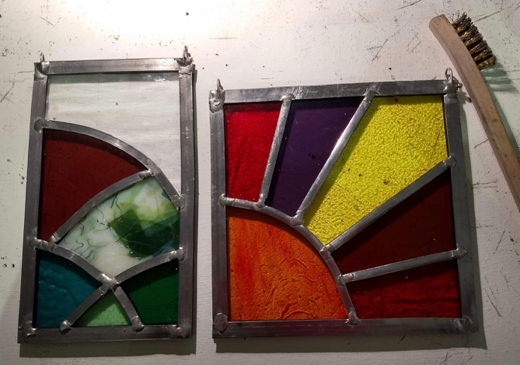
Student work

Session 1
- Introduction to cutting glass
- Making thumbnail designs for a simple panel with no more than 6 pieces and no larger than 18 x 18 cm square or 14 x 20 rectangular.
- Selecting and cutting the glass; using an easel

Session 2
- Preparing the glazing board
- Leading up
- Soldering and adding hanging hooks
- Cementing

Cost
£120 for one student; £180 for two booking at the same time. Glass cost in the region of £25 per student, depending on your choices.

Please ask me about supporting you to achieve other projects you have in mind.

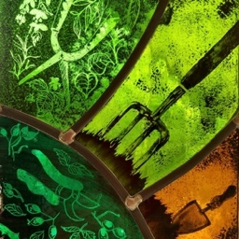

anna@annagillespieglass.co.uk

