Anna Gillespie Glass Courses

Making a Fused Glass Hanging

A one day Introductory Workshop; one to one or one to two tuition

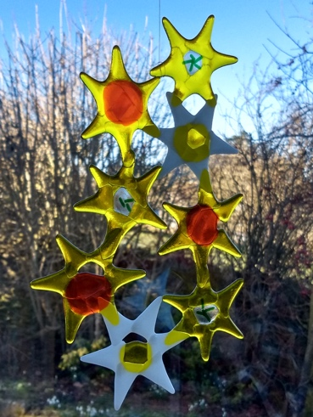

Daffodils,©Anna Gillespie

Learn how to create a fused glass hanging for the garden or indoors; please come with sketches or photos of flowers if you wish.

- Introduction to fusing glass – a few technicals
- Introduction to cutting glass
- Making designs for a hanging, based on spring flowers
- Selecting and cutting Spectrum glass
- Assembling ready for firing; loading the kiln
- Playtime: experiment with using window glass, frit, copper wire, foil, creating a second piece

You will need to collect your work after firing.

Cost
£120 for one student; £180 for two booking together. Glass cost in the region of £30 per student, depending on your choices.

Please ask me about supporting you to achieve other projects you have in mind.

Anna Gillespie
anna@annagillespieglass.co.uk

