Anna Gillespie Glass Courses

Mirror, Mirror

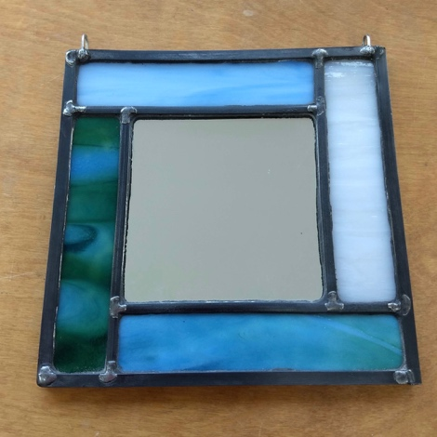

Mirror based on the Undercliff, near Brighton
©Anna Gillespie

One day or two half day sessions; one to one or one to two tuition.

Make a small mirror, based on the colours of a landscape. Please bring either a painting or a photograph of a landscape you know and love.

Session 1
- Introduction to cutting glass
- Making thumbnail designs for a square or rectangular mirror with a simple frame
- Selecting and cutting the glass – we will be using opaque glass for a wall-mounted mirror

Session 2
- Preparing the glazing board
- Leading up
- Soldering and adding hanging hooks
- Cementing

Cost
£120 for one student; £180 for two booking together. Glass cost in the region of £25 per student, depending on your choices.

Please ask me about supporting you to achieve other projects you have in mind.

Anna Gillespie
anna@annagillespieglass.co.uk

