Anna Gillespie Glass Courses

Next Steps: Drawing from Nature

One whole day and one half day session, 1:1 or 1:2 tuition.

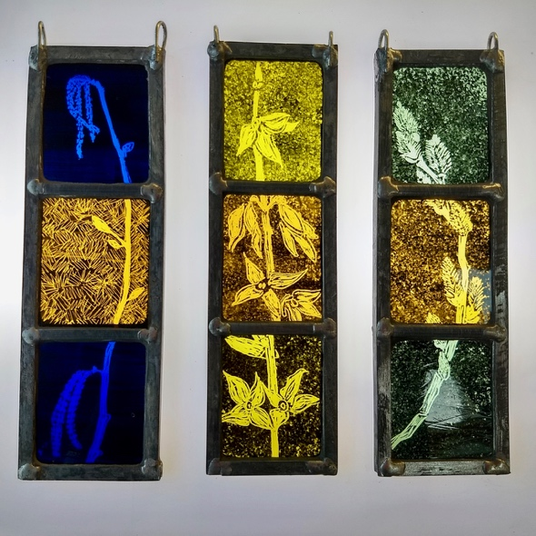
Signs of Spring
©Anna Gillespie

This is a follow-on course for those who have done an introduction to making stained glass.

We will draw plants in the garden and then make a small painted panel based on those drawings. The panel will be no larger than 18 x 18 cm and have no more than 6 pieces.

Session 1 (whole day)
- Drawing from Nature
- Making thumbnail designs for a simple panel
- Selecting and adapting for practicality, drawing the cut line
- Selecting and cutting the glass; using an easel
- Preparing glass paint
- Applying paint with brushes, sponges, stencils
- Drawing into a matt of paint

Firing provided

Session 2 (half day)
- Assessing the results of the firing
- Preparing the glazing board
- Leading up
- Soldering and adding hanging hooks
- Cementing

Cost
£180 for one student; £270 for two booking together. Glass cost in the region of £30, depending on your choices.

Please ask me about supporting you to achieve other projects you have in mind.

